InsightStream

# 1.Introduction

### • Project Title: InsightStream

### • Team ID : NM2025TMID36044

### • Team Leader: Triveni K – [udcu24s1032@gmail.com](mailto:udcu24s1032@gmail.com)

### • Team Members:

MAHALAKSHMI S - [udcu24s1006@gmail.com](mailto:udcu24s1006@gmail.com)

SARANYA S - [udcu24s1004@gmail.com](mailto:udcu24s1004@gmail.com)

KAVIPRIYA S - [udcu24s1007@gmail.com](mailto:udcu24s1007@gmail.com)

MEENAKA P - [udcu24s102006@gmail.com](mailto:udcu24s102006@gmail.com)

# 2. Project Overview

## • Purpose:

SB Works connects clients and freelancers through project postings, bidding, and real-time communication

## . • Features:

– Project posting and bidding

– Secure chat system

– Feedback and review system

– Admin control panel

# 3. Architecture

## • Frontend:

React.js with Bootstrap and Material UI

## • Backend:

Node.js and Express.js managing server logic and API endpoints

## • Database:

MongoDB stores user data, project information, applications, and chat messages

# 4. Setup Instructions

## • Prerequisites:

– Node.js

– MongoDB 2

– Git

– React.js

– Express.js – Mongoose – Visual Studio Code

## • Installation Steps:

# Clone the repository git clone

# Install client dependencies cd client npm install

# Install server dependencies cd ../server npm install

# 5. Folder Structure

SB-Works/

|-- client/ # React frontend

|__components/

L__ pages/

|__ server/ # Node.js backend

|__routes/

|__ models/

|__ controllers/

# 6. Running the Application

## • Frontend:

Cd client

npm start

## • Backend:

Cd server npm

start

## • Access: Visit <http://localhost:3000>

# 7. API Documentation

## • User:

– /api/user/register

– /api/user/login

## • Projects:

– /api/projects/create

– /api/projects/:id

## • Applications:

/api/apply

## • Chats:

– /api/chat/send

– /api/chat/:userId

## 8. Authentication

• JWT-based authentication for secure login

• Middleware protects private routes

## 9. User Interface

• Landing Page

• Freelancer Dashboard

• Admin Pane

• Project Details Page

## 10. Testing

• Manual testing during milestones

• Tools: Postman, Chrome Dev Tools

## 11. Screenshots or Demo

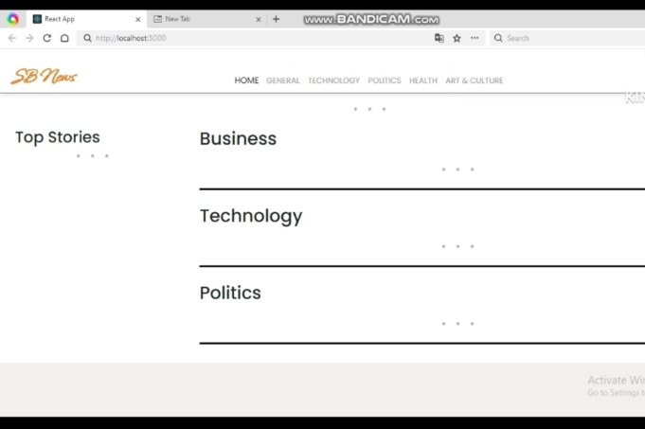

12. Known Issues : NILL

## 13. Future Enhancements:

A comprehensive platform that ingests user-generated content, analyzes it with LLMs, and delivers personalized recommendations using Redis as the real-time backbone.